Chemistry 115 Name
Dr. Cary Willard
Exam 1B September 17, 2008

 | Points Earned | Points Possible
Part 1  multiple choice |  | 30
Part 2  nomenclature |  | 8
Page 3 |  | 32
Page 4 |  | 30
Total |  | 100

Note: All work must be shown to receive credit. On calculation problems show answer with the correct number of significant figures using scientific notation if necessary.

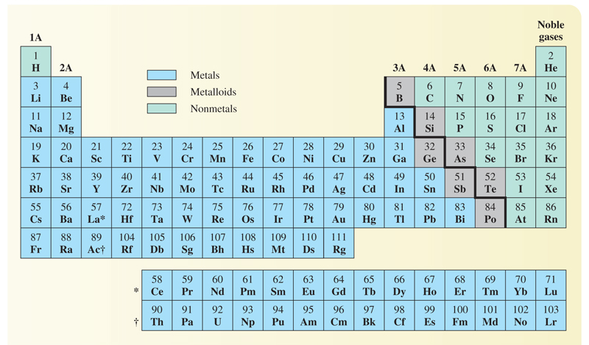
Part 1 – Multiple Choice (30 points)

- Why study chemistry?
  - To help us learn a technique for identifying and solving problems
  - To help inform us about our world
  - To be better able to make informed decisions
  - All the above

- A simple statement of natural phenomena to which no exceptions are known under given conditions is a(n)

  - scientific law
  - theory
  - observation
  - model

- Which is a mixture?

  - copper wire
  - sugar
  - mud
  - water

- How many significant figures are in the number 1.500?

  - 1
  - 2
  - 3
  - 4

- One centigram is equal to

  - 1000g
  - 100g
  - 0.01g
  - 0.001g

- Subtract 14.3 from 130.670. The difference expressed to the correct number of significant figures is

  - 116
  - 116.3
  - 116.37
  - 116.4

- The space occupied by a sample is its

  - Volume
  - Length
  - Mass
  - Temperature

- When expressed in proper scientific notation the number 0.00364 is

  - 3.64 X 10⁻³
  - 3.64 X 10⁻²
  - 3.64 X 10³
  - 3.64 X 10²

- Which type of element has the following general properties: low melting point and density, lacks luster, poor conductor of heat and electricity, and brittle?

  - Metal
  - Nonmetal
  - Transition element
  - Metalloid

- The charge of a cation is

  - Positive
  - Negative
  - Neutral

- How many atoms of oxygen are indicated in the formula Fe(NO₃)₂?

  - 2
  - 3
  - 5
  - 6

- Which chemical symbol is properly written?

  - ca
  - CO
  - Cu
  - CL

- Which is a halogen?

  - Calcium
  - Chlorine
  - Helium
  - Potassium

- Which is a chemical change?

  - Water freezing
  - Ice melting
  - Alcohol evaporating
  - Iron rusting

- Carbon, when burned completely, forms carbon dioxide. If 11.7g of carbon combines with 31.3g of oxygen, what mass of carbon dioxide will be produced?

  - 11.7g
  - 43.0g
  - 19.6g
  - 31.3g

Part 2 – Nomenclature (8 points)

Fill in the following chart with the correct name or formula for the following elements and compounds.

Compound / Element Name | Formula / Elemental Symbol
Beryllium
Potassium
 | I
 | Zn
Calcium oxide
Iron(III) chloride
 | PBr₃
 | CoCl₂

Part 3 – Problems and Questions (62 points)

- (6 points) Evaluate each of the following expressions. State the answer to the proper number of significant figures.

  - 53.92 + 1.4 + 0.47=

  - $\frac{0.8411}{52.8}$=

- (8 points) Complete the following metric conversions using the correct number of significant figures
  - 5.66 cm to mm

  - 41.5 mL to L

- (8 points) Complete the following American / metric conversions using the correct number of significant figures
  - 0.46 m to in

  - 7.6 qt to mL

- (5 points) Complete the following temperature conversion
253 ºF to ºC

- (5 points) Distinguish between homogeneous and heterogeneous mixtures. Give an example of each.
- (5 points) A strong camel can carry 925 lb. If one straw weighs 1.8 grams, how many straws can the camel carry without breaking his back? Give answer in scientific notation.

- (5 points) The density of a sulfuric acid solution is 1.26 g/mL. What volume of the solution will weigh 275. grams?

- (5 points) How many atoms of oxygen are there in exactly eight seven dozen molecules of nitric acid, HNO₃?

- (5 points) What is the fundamental difference between a chemical change and a physical change?

- (5 points) A 9.64 g sample of a biological molecule contains 6.52 g of carbon. What is the mass percent of carbon in the compound?

- (5 points) A can of soda contains 20.4 % sugar by mass. How many grams of soda will contain 525 grams of sugar?

